Lent, Holy Week, and Easter 2020
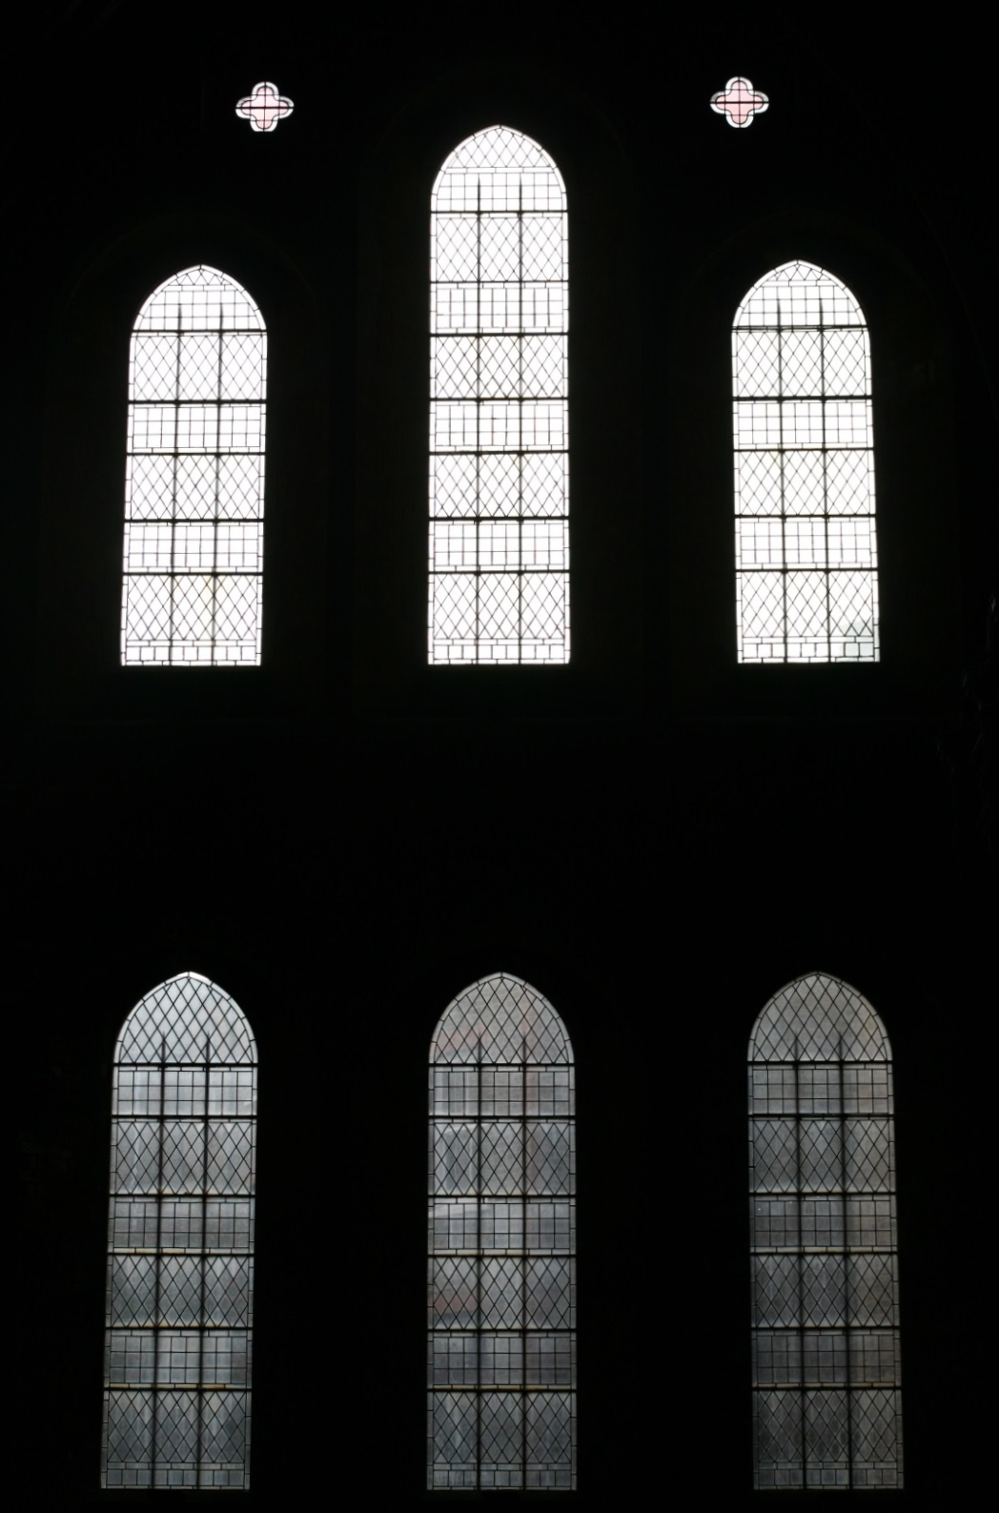

The Church of The Holy Innocents
Paddenswick Road W6
Lent at The Church of The Holy Innocents

Services in Church

Ash Wednesday, 26th February
7.30 am Holy Eucharist with Imposition of Ashes
7.30 pm Holy Eucharist with Imposition of Ashes

Weekdays in Lent
Thursdays 10.00 am Holy Eucharist

Saturdays, by appointment: Sacrament of Reconciliation

Thursday 19th March (St Joseph)
7.30 pm Parish Eucharist
followed by a study group

Sunday 22nd March (Mothering Sunday)
10.00 am Parish Eucharist – All-Age worship

Wednesday 25th March (The Annunciation)
7.30 pm Parish Eucharist
followed by a study group

Saturday 28th March
10.00 am Quiet Morning

Sunday 29th March (Passion Sunday)
10.00 am Parish Eucharist
followed by the Annual Parochial Church Meeting

Saturday 4th April
10.00 am Quiet Morning

Holy People, Holy Things:
Tradition, Mission and Ministry in the 2020s

Sundays in Lent

Following the Parish Eucharist, share in conversation and reflection on what it means to be The Church in Hammersmith. What are the challenges and hurdles facing our mission? How do we maintain and enliven our traditions and customs? What does living a life of faith look like in this new decade?

March 1 – Music and Liturgy, Prayer and The Sacramental Life

Baptism and the Eucharist are at the heart of our Calling. How do we reach out to the unchurched through the Sacraments? How do we enrich our tradition of music and worship? What does commitment to worship look like in the 2020s? Do we Pray as we ought?

March 8 – Teaching and Preaching, Sharing the
Good News of Jesus Christ

Scriptural and theological literacy are necessary building blocks to the life of faith. How do we provide teaching and inspire Evangelism in the streets of our Parish? To what ministry of service are you called? How do we encourage a life-long faith and loving Discipleship?

March 15 – Fabric and Finance, Stewardship of God's Gifts

Our church building tells a multi-generational story and offers an invitation to explore a tradition of faith. How do we harness the potential of our building without being overwhelmed by its scale and costs? How do we look after what God has given us and safeguard it for the future?

March 22 - Healing and Wholeness, Diversity and Justice

Our Church Family is inclusive and welcoming. So we say, but are we really?

March 29 – The Annual Parish Church Meeting

Our Annual Parish Church Meeting is the culmination of our Lenten discussions as we put our conversations into practice and focus our actions for the coming years.

Thursdays in Lent

10.30 am Following the Holy Eucharist, discuss your Lenten Reading over coffee.

Thursday, March 19 The Feast of St Joseph 7.30 pm

Holy Eucharist followed by
In the Absence of Joseph: A Reflection on The Holy Family and The Way of the Cross.
We consider the dynamics of the Holy Family and the memory of St Joseph by reflecting on Scripture and the Stations of the Cross.

Wednesday, March 25 The Feast of The Annunciation 7.30 pm

Holy Eucharist followed by
Stories Around the Fire: Preparing for Resurrection.
We reflect and meditate on The Easter Vigil cycle of paintings by John Afflick in the Chancel.

Saturday, March 28 Quiet Morning 10.00 am

Come spend two hours in quiet contemplation as we begin Passiontide.

Saturday, April 4 Quiet Morning 10.00 am

Come spend two hours in quiet contemplation as we begin Holy Week.

Lent Course 2020 - Religious Music in the Renaissance

Wednesdays, 4 March – 1 April 7.00 pm
Flat 6, Pocklington Lodge, Rylett Rd, W12 9PQ

A non-academic survey of developments, principal composers and their music in the context of church history and other cultural factors which impacted on them and their work. Sung texts with translations, historical notes and jargon-busting. Led by Mother Paulette and Dennis Sommers.

Dennis Sommers graduated from the Royal College of Music where he taught Music History & Appreciation for several years before turning pro. For nearly 20 years he served as Licenced Lay Minister at St Saviour’s, Cobbold Rd.

Tel: 0208 749 1443/07713 901 001
Email: sommers702@btinternet.com

Inspiring Music – A self-guided tour

Another chance to work through the history of sacred music, with a piece to listen to each day from Ash Wednesday to Easter – or in blocks if you prefer. All 40 pieces are available to listen to on the internet and links to the recordings are available on the Parish Website.
Curated by Jean-Paul Sinclair and Fr David.

What is Lent?

Lent is a season of repentance (turning again) and rededication of our lives to God in preparation for the coming Passion season and the renewal of Easter. It is a time for us to understand our inability to escape sin on our own and our reliance on the Holy Spirit to move us toward the life Jesus has called us to. This is expressed through a season of prayer and fasting, preparing ourselves for Holy Week.

The word Lent is derived from the Old English word for spring, referring to the lengthening of days. Originally it was known as the ‘Lenten fast’ but over the centuries contracted to simply ‘Lent’. Only English uses a word with this root. The French ‘Carême’ and Spanish ‘Cuaresma’ are derived from the Latin quadragesima “fortieth day before Easter”, while the German ‘Fastenzeit’ describes the characteristic activity of the season.

Forty …

The measure of forty days is often used throughout the Bible as a time of preparation, purification, repentance and renewal. Moses spent forty days on Mount Sinai. There were forty days of rain in the time of Noah. The Israelites spent forty years wandering in the desert as a result of their unbelief. Jesus spent forty days in the wilderness following his baptism.

The forty days of Lent can be counted in different ways, but the most usual way is to begin on Ash Wednesday and end on Holy Saturday, six weeks and four days (46 days) later, but excluding the six Sundays as Sunday is always a feast day, a ‘mini-Easter’.
Spiritual Disciplines

The observance of Lent began in the second century as a time of intense training and discipleship for new believers in preparation for their baptism at the Great Vigil of Easter. Often the whole church would join in fasting with them. As Christianity became more widespread, and infant baptism became the norm, the meaning of the season extended to be a time of re-preparation for the whole community, reflecting on our failures, giving thanks for our deliverance through the Cross, and resolving to follow Jesus more faithfully.

Prayer

Particularly during Lent, prayer has a vital place in our lives. Just as Jesus set aside time to be alone in prayer to prepare for major events or changes, so we’re called to set aside time to communicate with God.

Verbal prayer is perhaps the form we’re most familiar with. During Lent one might, for example, resolve to say Morning and/or Evening Prayer each day using the Common Worship form, or perhaps to set aside a daily quiet time of more free-form prayer, possibly using the Adoration, Confession, Thanksgiving, Supplication (ACTS) structure.

Prayer may also take non-verbal forms. Lectio Divina is an ancient practice of the church, consisting of choosing a passage of scripture and reading it several times, slowly, reflectively and prayerfully, allowing space for the Spirit to speak through the words. Our reading list includes books of scriptural reflections which may be helpful in scripture-based prayer.

Silent meditation, or meditation using repetitive focus words, phrases such as the Jesus prayer (Lord Jesus Christ, Son of God, have mercy on me, a sinner), or focusing on a candle, ikon or other image, can also be a helpful practice during Lent. Christian meditation, after all, predates mindfulness by many hundreds of years!

Fasting

“First, let [fasting] be done unto the Lord with our eye singly on Him. Let our intention herein be this and this alone, to glorify our Father which is in heaven” John Wesley

As part of the Lenten examination of our lives and growing closer to God, fasting is a spiritual discipline of self-sacrifice long practiced to help bring focus off ourselves (and our worldly hungers) and onto God. Jesus fasted forty days in the wilderness after his baptism, as part of his preparation for ministry. This level of self-discipline is unpopular in our current culture where every appetite must be met. Nonetheless, fasting can be helpful in unearthing things that control us or otherwise have unhealthy holds on our lives. Fasting need not mean complete abstinence from food – for example it could be missing one meal each week and giving the cost to charity or, as in the Roman church, abstaining from meat on Fridays.

Study

Spiritual disciplines are, at their heart, life-giving habits. Study is the discipline of building life-giving habits for our minds. In focussing on study we are choosing to avoid distractions and to search for truth and meaning in our chosen discipline.

As noted above, we are offering a range of Lent teaching this year, taking as a common theme what it means to be a church in Hammersmith and what living a life of faith looks like in this new decade.

And, as always, we offer a selection of book suggestions for private study and reflection, at the back of this leaflet.

Giving up / Taking Up

A tradition of giving up items for Lent has grown up over the centuries. By giving up something important we learn self-discipline and, in a small way, join in the suffering of Jesus. It can also be done as an expression of sorrow over sin. As we crave the item we’ve given up we must seek our strength in God and realise our own weakness.

More recently, the concept of “taking up” something has come into favour. Building upon Jesus’s command to take up our cross daily, we can take up charity work, doing acts of kindness, fighting injustice, or take up study/reading a book to focus ourselves on repentance or discipleship.

Almsgiving

The traditional practice of giving to the poor can be expressed through a response to the Bishop of London’s Lent Appeal. This year’s Lent Appeal, “Hidden in Plain Sight”, asks us to face the reality of modern slavery in our City today. It supports five charities working to end modern slavery in London.

Lent may also be an appropriate time to reflect on the level of our giving to support our Parish Church – to ask, as Wesley put it “how much of God’s money should I be keeping for myself?”.

Other Lenten disciplines can work in tandem with this – for example a sponsored giving-up or taking-up, or setting aside the cost of something given up for Lent, to raise funds for an appropriate cause.

Service

Another valuable Lenten discipline can be acts of personal or corporate service. These can be formal commitments, such as beginning to volunteer at a homeless shelter, food pantry or debt advice centre, or individual acts, such as stopping to chat with the homeless person outside the tube station or shopping for a housebound neighbour. We are always called to these acts of service, but perhaps Lent can provide an impetus to get started.

Penance

Lent being a time of repentance and rededication of our lives to God, our observance can sometimes take on the form of penance. Penance is a refocussing and an outward expression of a contrite heart which can take many forms. Any of the disciplines already mentioned can – but need not – be undertaken as an act of penitence. While the forms may be varied, the focus is always as much forward as backward-looking: like the woman saved from stoning in John 8.11, we both gratefully accept our deliverance and resolve to sin no more.

There should be both individual and corporate confession both for actions and for failures to act. Our corporate liturgical confession during the Mass takes a more prominent place during Lent, highlighted by the absence of the Gloria.

Individual sacramental confession is a practice of which the Church of England teaches “everyone may, none must, some should”. Many people find this sacrament helpful as a way of dealing with the guilt and resentment that can sometimes come between us and God, as well as between ourselves and others.

Whether corporate or individual, the sacrament of reconciliation marks a turn away from sin and a return to God, accompanied by the assurance that through Christ our sins are forgiven.

Liturgical Observance of Lent

Ash Wednesday

Marking the beginning of Lent, Ash Wednesday establishes the tone of repentance and rededication for the season. The ashes used in the liturgy, made from last year’s Palm Sunday crosses, are a visible sign of mourning our sins, of repentance and a reminder of our own mortality.

“Remember that you are dust and to dust you shall return.” Ecclesiastes 3:20

“Therefore I despise myself, and repent in dust and ashes.” Job 42: 6

This is a moment of reminder that the world does not revolve around us. The day is often marked with fasting.

Joseph of Nazareth, 19th March
The Annunciation, 25th March

These celebrations of Joseph and Mary are not out of place during the sacrificial season of Lent. Both Mary and Joseph displayed a sacrificial turning away from their former lives and entrusted themselves to God’s plan for them. Mary responded in trust and obedience to the message of God announced by Gabriel. Joseph too obeyed the angel’s instruction, defying social convention to remain at Mary’s side when God’s promise became a visible reality.

Mothering Sunday, 22nd March

This fourth Sunday of Lent is also known as Laetare Sunday, from the opening words of the Latin introit for this day, Laetare Ierusalem – Rejoice, O Jerusalem. In the English church this became a traditional day for domestic servants to return to their home towns, to visit their ‘mother churches’ and also for parishioners to visit the cathedral or ‘mother church’ of the diocese.
By extension it is a time for all Christians to celebrate the Church as our mother. As the secular ‘Mothers’ Day’ grew in popularity during the 20th century, in the UK the traditional ‘Mothering Sunday’ observance widened its focus to include celebration of our human mothers.

The 10.00 am Parish Eucharist on Mothering Sunday will be All-Age Worship.

Passiontide

Passiontide refers to the last two weeks of Lent as we recall how Jesus ‘set his face to go to Jerusalem’ (Luke 9.51) and the inevitability of his death. Historically the fifth Sunday of Lent was known as Passion Sunday, marked by the reading of the Passion narrative from the Gospel of the year. From this Sunday onward it is customary for the statues, icons and objects of devotion in church to be veiled.

Palm Sunday

Palm Sunday marks the arrival of Jesus in Jerusalem. Its mixed emotions are summed up in the words of the Palm Sunday hymn, “Ride on, ride on in majesty! In lowly pomp, ride on to die.” Jesus’s triumphant entry, symbolically mounted on a donkey to claim Zechariah’s prophecy of the coming Messiah, is greeted by crowds shouting ‘Hosanna’, an Aramaic word meaning “save us now”. Jesus’s entry into Jerusalem was at the same time a day of great joy and expectation, and also the beginning of his inexorable journey to the cross.

The Palm Sunday tradition of a procession through the streets, waving palm leaves, which are then folded into the shape of a cross, similarly evokes the mixed emotions of that day.

Holy Week

And so begins our pilgrimage to the foot of the cross. On Monday and Tuesday our Gospel readings at the Parish Eucharist are from John, the anointing at Bethany and Jesus’s foretelling of his death, as the tension builds towards its climax.

On Wednesday evening at The Church of The Holy Innocents we have a service of Tenebrae, a traditional service derived from the monastic offices of Mattins and Lauds. As the chants are sung, the lights in the church are extinguished one by one until the church is left in silent darkness.

The Triduum

The Triduum is the three-day period beginning in gathering gloom on the evening of Holy (Maundy) Thursday and ending with the joyous celebration of Easter morning.

Holy Thursday

Also known in the English church as Maundy Thursday, from ‘mandatum’, commandment, recalling the ‘new commandment’ Jesus gave his disciples as he prepared to be betrayed: “love one another, as I have loved you”.

On Maundy Thursday we recall the events of the Last Supper and the institution of the celebration of Holy Communion. According to John’s Gospel, the evening began by washing the disciples’ feet, an act of the humblest service.

The synoptic Gospels describe a Passover meal, at which Jesus broke the bread, gave it to his disciples and said “take, eat, this is my body”. After supper he took the third cup of wine, the cup of redemption, and said “drink this, all of you, this is my blood”.

Jesus said “I will not drink again of the fruit of the vine until the Kingdom of God comes”; and after the Maundy Thursday Eucharist we do not consecrate bread and wine again until the celebration of the Kingdom on Easter morning. The remaining bread is set aside in the Garden of Repose, the altar is stripped bare, and we symbolically watch and wait with Jesus in the
Garden of Gethsemane.

Good Friday

The solemn liturgy of Good Friday recalls the trial, suffering, and crucifixion of Jesus as we journey with Jesus along the via Dolorosa, the Way of Sorrows. As Bishop Stephen Cottrell puts it, on Good Friday we seek not so much to understand the Cross as to stand under the Cross.

Reflective silence forms a vital part of the liturgy of Good Friday. The passion narrative from St John’s Gospel is read or sung. A crucifix is brought into church with the words “Behold the wood of the Cross on which was hung the Saviour of the World”. The congregation may perform an act of veneration, such as kissing the wood of the cross.

Communion is received in one kind only, from the reserved sacrament consecrated on Holy Thursday.

Holy Saturday

Holy Saturday is a day of profound emptiness.

It is not, though, a day to rush through in our haste to get to Easter. The joy of Easter is incomplete if it does not stand in contrast with the pain of Good Friday and the desolation of Holy Saturday. To remember this time when Jesus lay dead in the tomb is to remember that there is no part of our human existence that Jesus has not shared. Most of us have experienced loss in our own lives, and Holy Saturday is a reminder that Jesus, in the most profound way, is with us in that loss.

The Great Vigil of Easter

In the deepest darkness, outside the church a new light is kindled and the fire is blessed. The Paschal Candle is studded with the nails of the crucifixion, before being lit from the new fire and then carried into the dark church. In the candlelight the Exsultet, the ancient hymn of praise, is sung. A series of readings follows, recalling the faithfulness of God from the creation, through the Exodus, into the now-fulfilled promises through the prophets.

The priest proclaims the resurrection of Christ and a joyful cacophony breaks out. The church is flooded with light and we see it decorated in all its Easter glory as the Gloria in Excelsis is sung.

The Liturgy of the Word follows, and then the Liturgy of Baptism, traditionally for the welcome of new believers into the church, and now also for the renewal of baptismal vows by the whole congregation.

We celebrate the Eucharist together, rejoicing in the assurance that, as Christ has shared in our death, so we will share in his resurrection.

Easter Day

After the excitement of the Vigil, Easter morning marks the beginning of our fifty days of Easter joy. Alleluia, having been excised from our liturgy during Lent, becomes the joyful refrain of this season.

Alleluia, Christ is Risen!
He is Risen Indeed, Alleluia!

Reading suggestions for Lent

Mark Barrett - The Wind, The Fountain and the Fire: Scripture and the Renewal of the Christian Imagination (The 2020 Bloomsbury Lent Book).
London: Bloomsbury, 2019.

Christina Beardsley and Michelle O'Brien, eds - This Is My Body: Hearing the Theology of Transgender Christians. London: Darton, Longman & Todd, 2016.

Mark Cocker - Our Place: Can We Save Britain's Wildlife Before It Is Too Late? London: Cape, 2018.

David Bentley Hart - The New Testament: A Translation.
London: Yale University Press, 2018.

Afua Hirsch - Brit (ish); On Race, Identity and Belonging. London: Cape, 2018.

Philip Jenkins - Crucible of Faith: The Ancient Revolution That Made Our Modern Religious World. London: Basic Books, 2018.

Mihee Kim-Kort - Outside the Lines: How Embracing Queerness Will Transform Your Faith. Minneapolis: Fortress Press, 2018.

Michael Mayne - Dust That Dreams of Glory: Reflections on Lent and Holy Week. Norwich: Canterbury Press, 2017.

Rebecca McLaughlin - Confronting Christianity: 12 Hard Questions for the World's Largest Religion. London: Crossway, 2019.

Catherine Nixey - The Darkening Age: The Christian Destruction of the Classical World. London: Macmillan, 2018.

Mark Oakley - My Sour-Sweet Days: George Herbert and the Journey of the Soul. London: SPCK, 2019.

Timothy Radcliffe - Alive in God: A Christian Imagination. London: Bloomsbury Continuum, 2019.

Ruth Valerio - Saying Yes to Life (The Archbishop of Canterbury's Lent Book 2020). London: SPCK, 2019.

Samuel Wells - Walk Humbly: Encouragements for Living, Working and Being. Norwich: Canterbury Press, 2019.

Rowan Williams - The Way of St Benedict.
London: Bloomsbury Continuum, 2020.

Tom Wright - Lent for Everyone: Matthew Year A. London: SPCK, 2011.

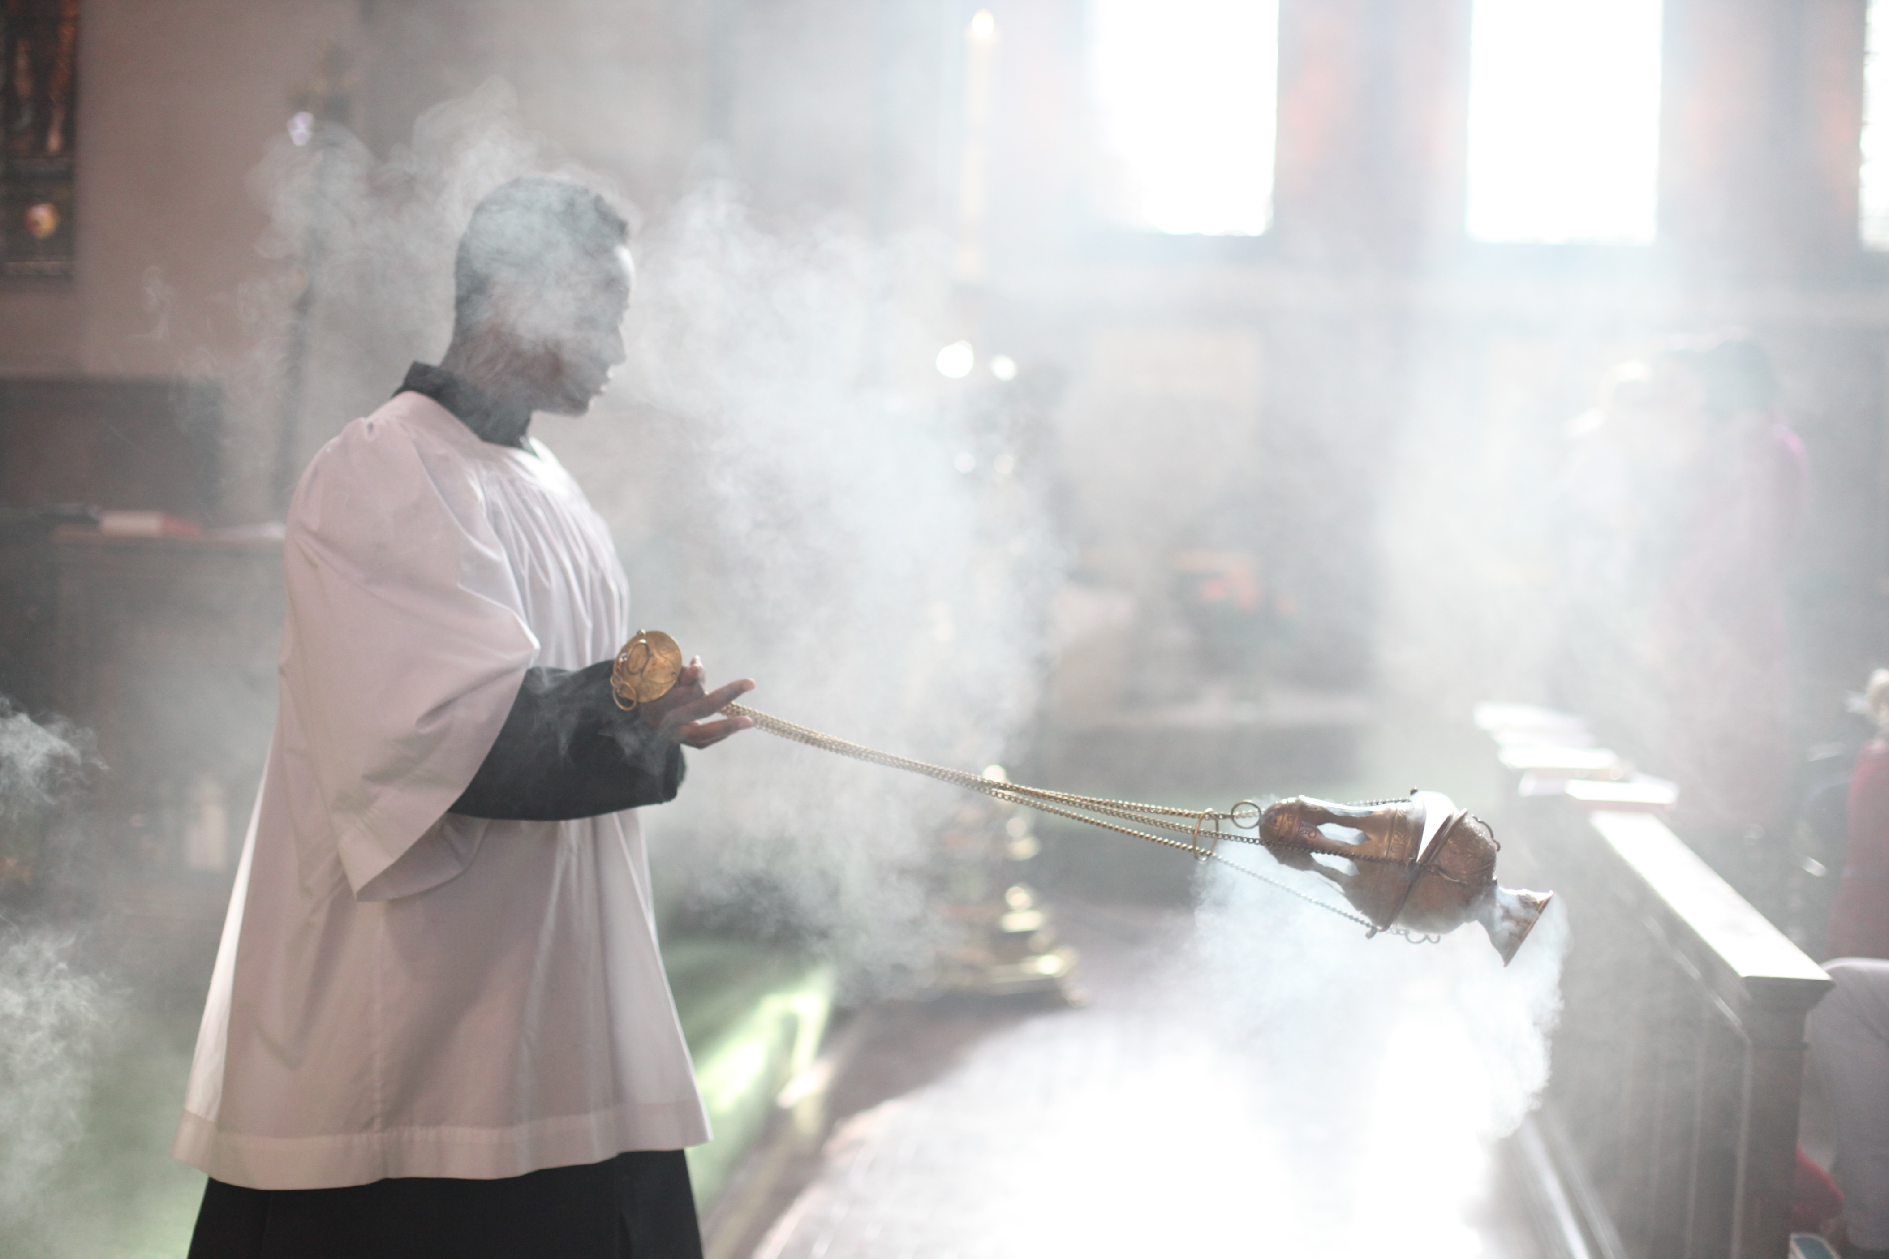
Services for Holy Week and Easter
Palm Sunday, 5th April
10.00 am The Liturgy of the Palms and Procession
from St John the Evangelist, Glenthorne Road

Monday in Holy Week, 6th April
7.30 pm Holy Eucharist with Homily

Tuesday in Holy Week, 7th April
7.30 pm Holy Eucharist with Homily

Wednesday in Holy Week, 8th April
7.30 pm Tenebrae of Maundy Thursday
Including The Lamentations of Jeremiah by Orlando de Lassus

Maundy Thursday, 9th April
10.30 am Chrism Mass with Renewal of Ordination Vows at St Paul’s Cathedral
7.30 pm Institution of Holy Eucharist
with the Washing of Feet; Stripping of the Altar followed by prayer at the Altar of Repose.

Good Friday, 10th April
11.00 am Stations of the Cross
12 Noon Liturgy of the Day with Reading of the Passion
Including a new setting of the Stabat Mater for Vocal Quartet
by Gary Peacock

Holy Saturday, 11th April
10.00 am Morning Prayer
10.30 am Cleaning and Decorating the Church
8.00 pm The Great Vigil of Easter

Easter Day, 12th April
10.00 am Holy Eucharist of the Resurrection

