REFLECTION for 3rd Sunday of Easter - 26th April 2020
The Service for Jennifer Gibson will take place on Tuesday, 28th April at 6pm.
Please hold Loretta and her entire family in your prayers at this time.
Luke 24:13-35
When this pandemic is over, a visit to the National Gallery is recommended. There will be found a famous painting by Caravaggio depicting the gospel story set for today. The painting is known as the Supper at Emmaus. It captures the moment when the disciples recognised the companion who had accompanied them to Emmaus. The faces and gestures of the disciples reflect their dawning realisation. Jesus is saying the prayer of thanksgiving over the food and wine, and, it is in this echo of the Last Supper that his disciples know him for who he is. The composition of the painting enables the viewer to draw close to the table – to join the group – to experience, and not merely observe, the drama of the moment when the reality of the resurrection bursts into the disciples’ lives.
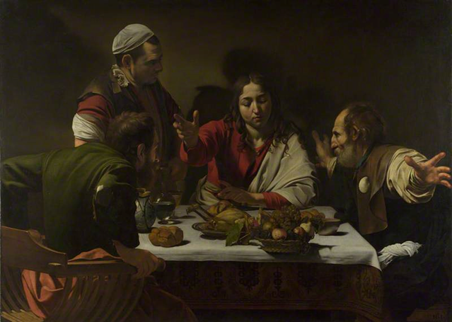
Rarely does the gospel tell us what to do or believe. Rarely does it give us a straight answer. And today’s gospel (Luke 24:13-35), the road to Emmaus story, is no different. It doesn’t give us answers. It raises questions and invites reflection. It’s a map by which we orient and find ourselves. It reveals intersections of Jesus’ life and our lives. It begs to be recognized as a story about our lives, and it is a story with which we are familiar. It is a story of shattering and of restoration.

The Gospel tells of the resurrected Christ’s appearance to two of the disciples. The women had already been to the tomb, found it empty, encountered two angels who reminded them that Jesus had said he would rise on the third day, and reported this momentous news back to the apostles. But they were not really believed, and only Peter bothered to go and check for himself.

We can only imagine how dejectedly the two disciples must have been, as they dawdled along the dusty road, going over things, wondering where it had all gone wrong. Certainly, the magnitude of recent events must have made them incredulous that their companion on the road seemed not to know about them. But the tables were soon turned, as he walked with them and explained their own experiences to them. However, although they must have heard much of it during Jesus’ teaching ministry, they still did not realise that it was he himself walking alongside them.

The disciples’ offer of hospitality is unsurprising – hospitality is essential in desert cultures, as a host’s failure to offer food, drink and shelter can condemn a traveller to death. There are echoes here of The Last Supper – an event which would have been fresh in the minds of the disciples. The words and actions of taking, blessing and breaking bread seem to be a conscious repeat of the events in the Upper Room. The disciples did not recognise the risen Christ through the word alone, but needed to experience the physical breaking of bread, which Jesus had instituted as the Eucharist only days before. It emphasises its importance as a way of encountering and recognising Christ. In our Eucharist week by week we follow this pattern of recognising Christ by both word and sacrament.

The two disciples immediately returned to Jerusalem to share their news. We can imagine their hurry back along the road they had dawdled along earlier, breathless and eager to tell what they had seen. They found the eleven gathered with others, burst in upon them, and told them of their travelling companion and – most importantly – that they had recognised him in the breaking of bread.

Jesus drew alongside his downcast disciples, asked what was preoccupying them and listened to their tale of woe. Only then did he seek to enlighten them about the scriptures, and about what had really happened in the crucifixion and resurrection.

He then reinforced the importance of the sacrament which he had instituted only a few days before at the Last Supper. Again, he revealed his glory through the act of taking, blessing and breaking bread.

There is a sense in this passage of the sanctification of the ordinary. Everyday things in life – a journey, a shared meal – become the means through which the glory of God is revealed. The challenge is for us to be aware of God’s presence and love in the ordinary, the everyday, the familiar, the mundane, as well as in the holy places of church and liturgy.

Jesus was in Jerusalem before Cleopas and his companion ever left. He was with them on the road to Emmaus. He was in the breaking of the bread. And he was already in Jerusalem when they returned. Do you know what those intersections are called?

They are called the gifts of God for the people of God.

